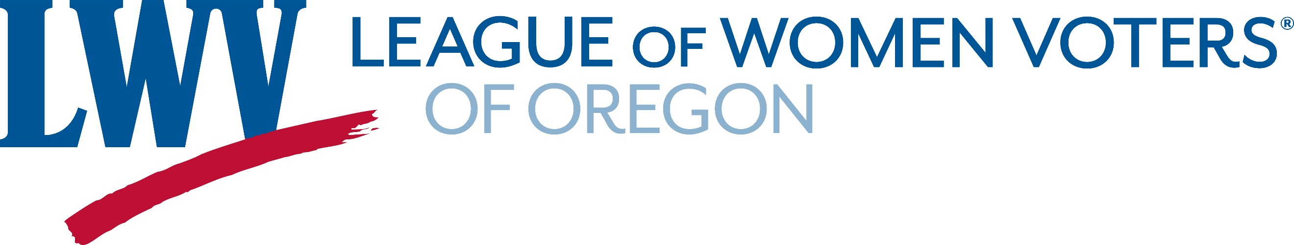
Hard Rock Mining Consensus Questions
Name of League/Unit: Number of Members Participating:
Contact Person: Contact phone/email:
Note: The consensus process is essential to the development of League position statements that reflect the views of our members. Local Leagues should form committees to guide members in discussion of the consensus questions. These discussion leaders should summarize member responses and include comments. Consensus means a general agreement by members, not a strict voting process, but including any vote taken in the comments is useful. Please include the number of League members participating in the consensus meetings. This is important in developing a final position statement for use in action. For Leagues with multiple units, a committee should combine the results and forward them to the LWVOR office.
- What factors should be included in the regulation and oversight of hard rock mining and processing?
a. Clear, comprehensive permitting process that includes adequate opportunities for public input
b. Environmental and health impacts on local communities (e.g., water quality, air quality, soil quality, wildlife preservation)
c. In-depth cost/benefit analysis that includes economic benefits to the local economy (e.g., increased jobs & wages, higher tax revenues) vs. cost to taxpayers (e.g., increased revenue needed for roads & other infrastructure, public safety, long term monitoring)
d. Impacts on other industries (e.g., agriculture, fishing, tourism, hunting, recreation, foraging, timber harvesting)
e. Public Safety (i.e., mine worker safety; impact from natural disasters, such as earthquakes, landslides, floods)
f. Long term monitoring and restoration costs
g. Other
Optional Comment

- What changes, if any, should be considered in the reform of federal hard rock mining laws?
a. Re-evaluate the historic directive that hard rock mining takes precedence over other uses of public land
b. Charge royalties for metal extraction on federal land to help pay for enforcement and monitoring
c. Place limits on ownership of hard rock mines by foreign companies
d. Ensure that hard rock mining operations, not taxpayers, bear the costs of mining clean up, reclamation, and long-term monitoring
e. Hold former owners of mining companies financially liable for reclamation costs
f. Strengthen protection of areas of critical environmental concern
g. Ensure that areas with special designations such as National Wild and Scenic Rivers, BLM Areas of Environmental Concern, forest Service Research Natural Areas, and Botanical Areas are off limits to mining
h. Streamline leasing, permitting, and oversight process
i. Other
Optional Comment
3. What changes, if any, should be made to Oregon mining laws?
a. Make it mandatory for mining operations to provide security or an annuity for post-reclamation monitoring.
b. Make bonding requirements sufficient to cover long-term site care and monitoring needs.
c. Take a more regional approach when crafting Oregon mining regulations to account for variations in population density, topography, climate conditions, and economic need.
d. Ensure that all Oregonians have a say in the use of public land
e. Other
Optional Comment
4. To promote economic development in parts of Oregon, should some taxpayer money be used to mitigate the high upfront costs of mine development, such as mapping, chemical analysis, and exploratory drilling?
Optional Comment
5. Should the state of Oregon develop programs to encourage recycling of metals and their alloys? (e.g., an initiative similar to the E-cycling program for electronic devices; grants or subsidies to encourage local companies to process, use, or manufacture products using recycled metals)
Optional Comment

